Algebra 1 Unit 2.1 Recovery Work

Algebraic Proofs:

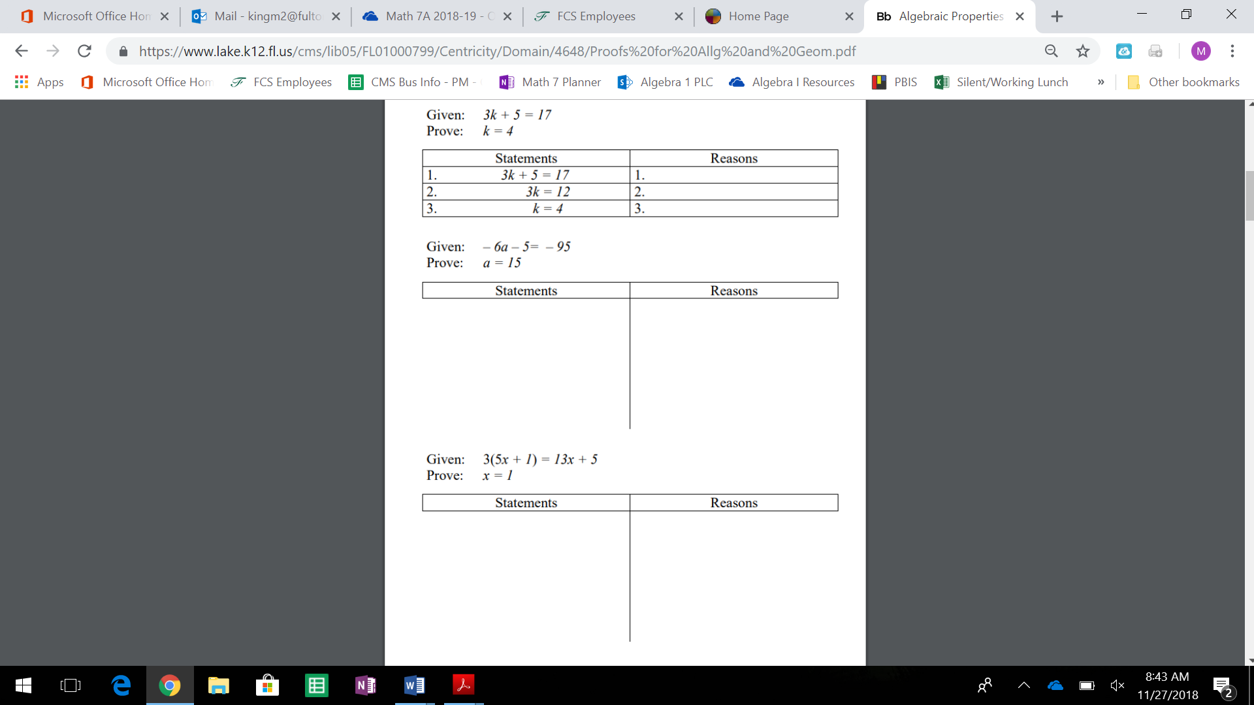

Equation Forms:

What is Slope-Intercept Form? _____________________________________________________________________

What is Point-Slope Form? ________________________________________________________________________

What is Standard Form? __________________________________________________________________________

1. Find the Point-Slope form of a line that goes through the points (-1,2) and (3,4).
   1. Write the equation in Slope-Intercept Form
   2. Write the equation in Standard Form
2. Find the Point-Slope form of a line that goes through the points (-1,-2) and (-4,1).
   1. Write the equation in Slope-Intercept Form
   2. Write the equation in Standard Form
3. Find the Point-Slope form of a line that goes through the points (-1,-3) and (3,-5).
   1. Write the equation in Slope-Intercept Form
   2. Write the equation in Standard Form

Inequalities

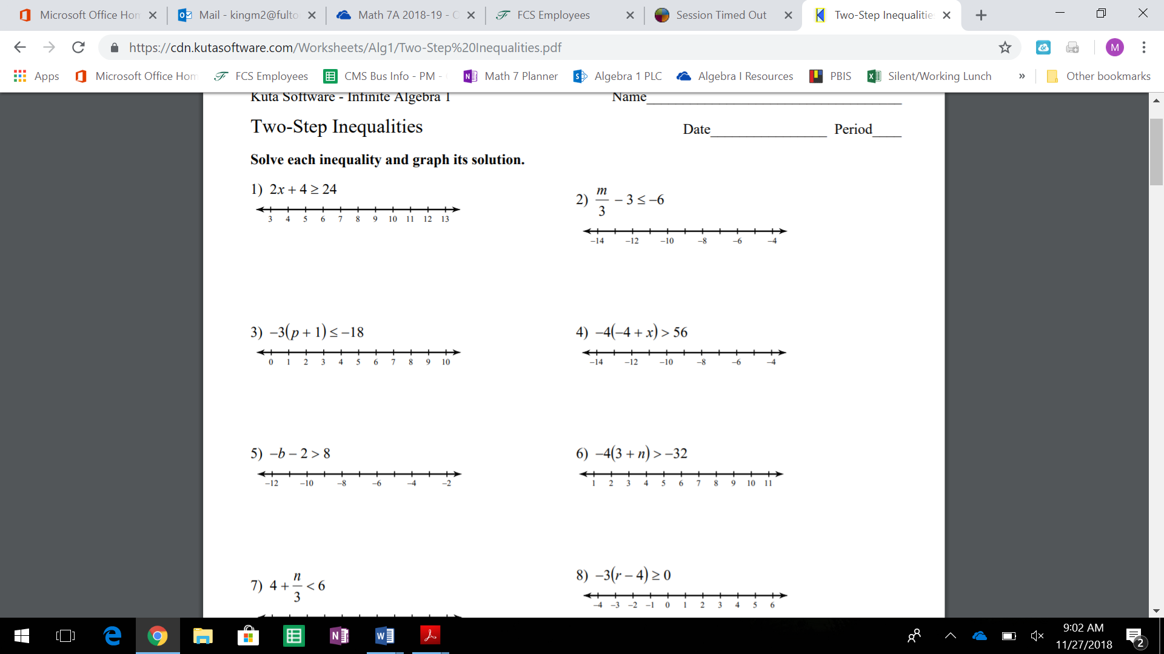

**For each of the following inequalities:**

**(a) Write the inequality algebraically.**

**(b) Graph the inequality on the real number line.**

**(c) Write the inequality in interval notation.**

1. *x* is greater than 5.
2. *x* is less than 4.
3. *x* is less than or equal to 3.
4. *x* is greater than or equal to 7.

**Write each of the following inequalities in interval notation.**

1. 
2. 
3. 
4. 

Solving Systems of Equations

