Name: ___________________________________________________
Unit 4: Exponential Functions Mock Test
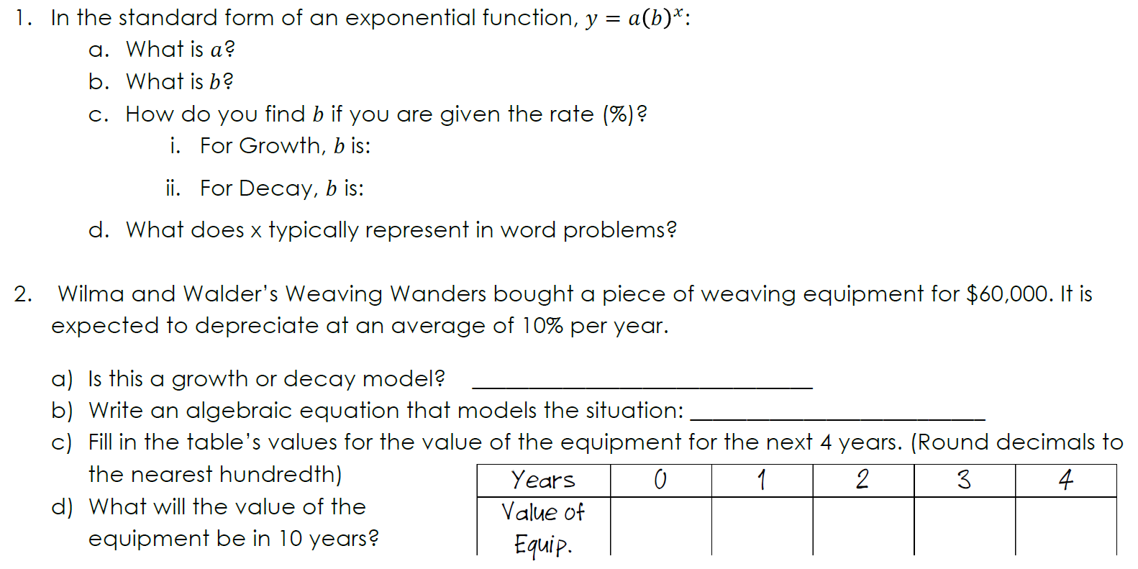

Solve the following Exponential Functions:
12. ${25}^{x-2}=\frac{1}{5}$ 13. ${27}^{-x+3}∙9^{x+1}=81$

14. $2^{x-1}∙4^{-1}=1$ 15. $\frac{7^{x-3}}{{49}^{x-3}}=7$

16. ${49}^{2x-1}=343$ 17. ${\frac{1}{12}}^{2x-4}=\frac{1}{144}$
20. What is an asymptote, and how can you find the asymptote in both the parent function f(x) = b^{x} and in the transformed function g(x) = ab^{x-h} + k?
__________________________________________________________________________________________________________________________________________________________________________________________________________________________________________________
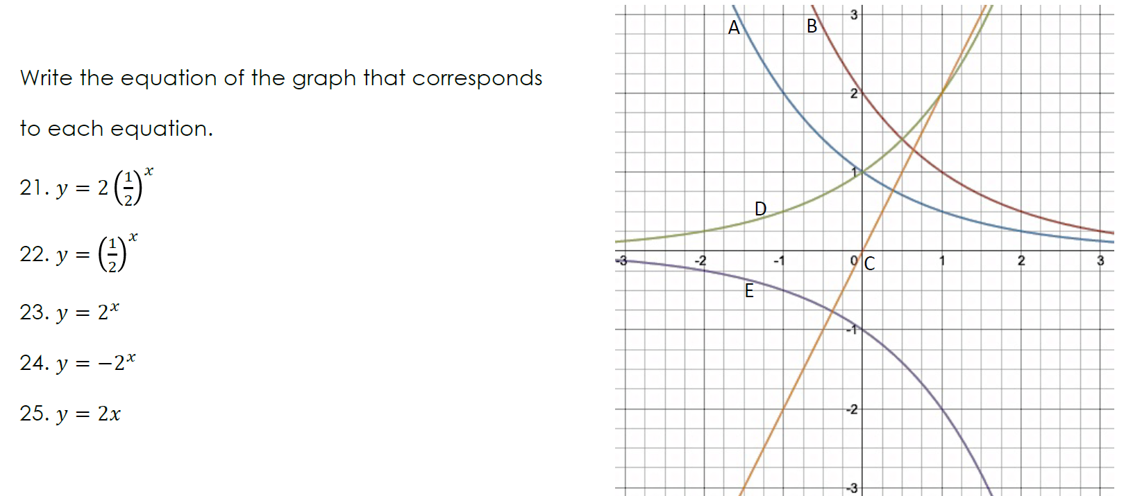
Answer the following about Geometric Sequences:
26. Find the formula for the nth term of the following geometric sequence: 3, 9, 27, 81, …

27. Find the formula for the nth term of the following geometric sequence: -2, 10, -50, 250, …

28. Lidia’s parents have offered her two different options to earn her allowance for a 9-week period over the summer. She can either get paid $30 each week, or $1the first week, $2 the second week, $4 the third week, and so on.
a) Clearly explain if the second option forms a geometric sequence or not.

b) Show work and explain which option Lidia should choose.

29. Find the common ratio for the following sequence, and then find the tenth term: 7, -7, 7, -7, …

30. The fourth term for a sequence is 54, and the common ratio is -3. Use the information to find the eighth term. (Hint: You will need to find A₁ first.)

