NAME: _______________________________________ Statistics Test Review HW

Standards to be Assessed: MGSE7.SP.1 Understand that statistics can be used to gain information about a population by examining a sample of the population; generalizations about a population from a sample are valid only if the sample is representative of that population. Understand that random sampling tends to produce representative samples and support valid inferences. MGSE7.SP.2 Use data from a random sample to draw inferences about a population with an unknown characteristic of interest. Generate multiple samples (or simulated samples) of the same size to gauge the variation in estimates or predictions. MGSE7.SP.3 Informally assess the degree of visual overlap of two numerical data distributions with similar variabilities, measuring the difference between the medians by expressing it as a multiple of the interquartile range. MGSE7.SP.4 Use measures of center and measures of variability for numerical data from random samples to draw informal comparative inferences about two populations.

1. Seventeen out of 20 teens said they eat breakfast  every morning. What is a reasonable prediction for the  number of teens out of 1,280 who eat breakfast every  morning? | 2. An internet company randomly selected 50 of its customers and asked them how many hours per week they use the internet. Of those surveyed, 28 use the internet more than 15 hours per week. Based on the data, if the company has 800 subscribers how many use more than 15 hours per week?

3. Identify the POPULATION and the SAMPLE in the situation.
Eighty-five percent of the student council plans to attend the Thanksgiving parade.

Population: _____________________________________________________________

Sample: _________________________________________________________________

4. Sierra’s monthly cell-phone bills were as follows: $150, $123, $210, $101, $130, and $150. Find the mean, median, mode, and range.
MEAN: | MEDIAN:
MODE: | RANGE:
For #5 – 8, use the following box-and-whisker plots.
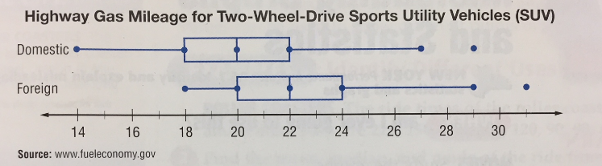

5. Describe the shape of the data for FOREIGN SUVs. ___________________________________________

6. What percent of these domestic SUVs get at least 20 miles per gallon? __________________%

7. What percent of these foreign SUVs get at least 20 miles per gallon? __________________%

8. What is the difference between the measures of center? ____________________________________

9. Find the interquartile range for each plot.

Domestic SUVS: __________________________ Foreign SUVs: ___________________________

10. The data below is from two random samples of 400 students regarding their favorite Olympic sport.
OLYMPIC SPORT | swimming | gymnastics | archery | cycling | TOTAL
NUMBER OF STUDENTS | 180 | 135 | 65 | 20 | 400

a.) What percent of the students prefer swimming? | b.) If this survey represented 3,000 students, how many would prefer gymnastics?

For #11 – 15, circle the correct answer.
11. Antwan wants to know how often the residents in his neighborhood go to the beach. Which sampling method will give valid results?
A. He asks all the members of the swim team at his school.
B. He asks all his family members and friends.
C. He posts a question on a community Web site.
D. He asks three random households from each street in his neighborhood.
12. Mr. Hou put student names in a hat and selected five names without looking. What type of sample did he form?
A. simple random sample B. systematic random sample
C. biased sample D. convenience sample

13. Katie and Danielle recorded their resting heart rates each morning for ten days. The double dot plot shows their heart rates in beats per minute.
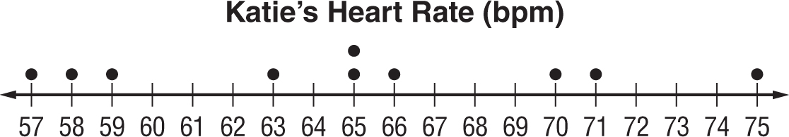

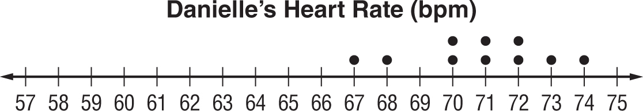

Which of the following statements is not true?
A. Katie has more varied resting heart rate.
B. Danielle’s heart rates peak between 70 and 72 minutes.
C. Katie’s heart rates peak at 65 minutes.
D. Katie has a greater average resting heart rate.

14. The number of pieces of mail the Smith and Gomez families receive is tracked over a period of two weeks. Which statement best supports the data?  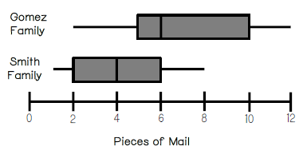  A.) The interquartile range of the data for the Gomez family is less than the interquartile range of the data for the Smith family.  B.) The data for the Smith family is more symmetrical than the data for the Gomez family.  C.) The median for the Gomez family is greater than the maximum for the Smith family. | 15. The dot plots below show the weight of newborn babies in two different hospitals. Which statement appears to be true?  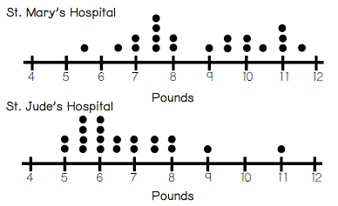  A.) The data for St. Mary’s and St. Jude’s are skewed left.  B.) The median weight at St. Mary’s Hospital is greater than the median weight at St. Jude’s Hospital.  C.) The range of the weight at St. Mary’s Hospital is greater than the range of weight at St. Jude’s Hospital.

