Name: ________________________________________________________ Test Date: _________________________________
Unit 3A: Proportionality Test Study Guide
Unit Rates:
- If Mark uses $3\frac{3}{4}$ tablespoons of coffee to make 10 cups of coffee, how much would he need to make one cup of coffee? | - Andre took a trip from Boston, Massachusetts to Paris, France. The plane took $6\frac{2}{3}$ hours to go $3,669\frac{4}{5}$ miles. How far did the plane travel in 1 hour?
- A standard bathtub holds 70 gallons of water. On average, it takes $7\frac{1}{2}$ minutes to drain a bathtub. How many gallons of water go down the drain each minute? | - Mackenzie ran the Olympic marathon of $26\frac{1}{5}$ miles in a time of $5\frac{4}{5}$ hours. How far did she run in the first hour?
- Tiana’s car travelled 111 miles on $\frac{3}{8}$ of a tank of gas. How far will she be able to go on a full tank of gas? | - Joey entered a hot dog eating competition. In $3\frac{3}{4}$ minutes, he ate $30\frac{1}{2}$ hot dogs. How many hot dogs did he eat in one minute?

Proportionality:
- Fill in the missing ratio values.  Is the table proportional? Explain why or why not: | - Find a real-world example of a proportional relationship. _______________________________________________  ______________________________________________________________  ______________________________________________________________  ______________________________________________________________  ______________________________________________________________  How could that relationship be changed to become non-proportional? ________________________________________  ______________________________________________________________  ______________________________________________________________  ______________________________________________________________  ______________________________________________________________
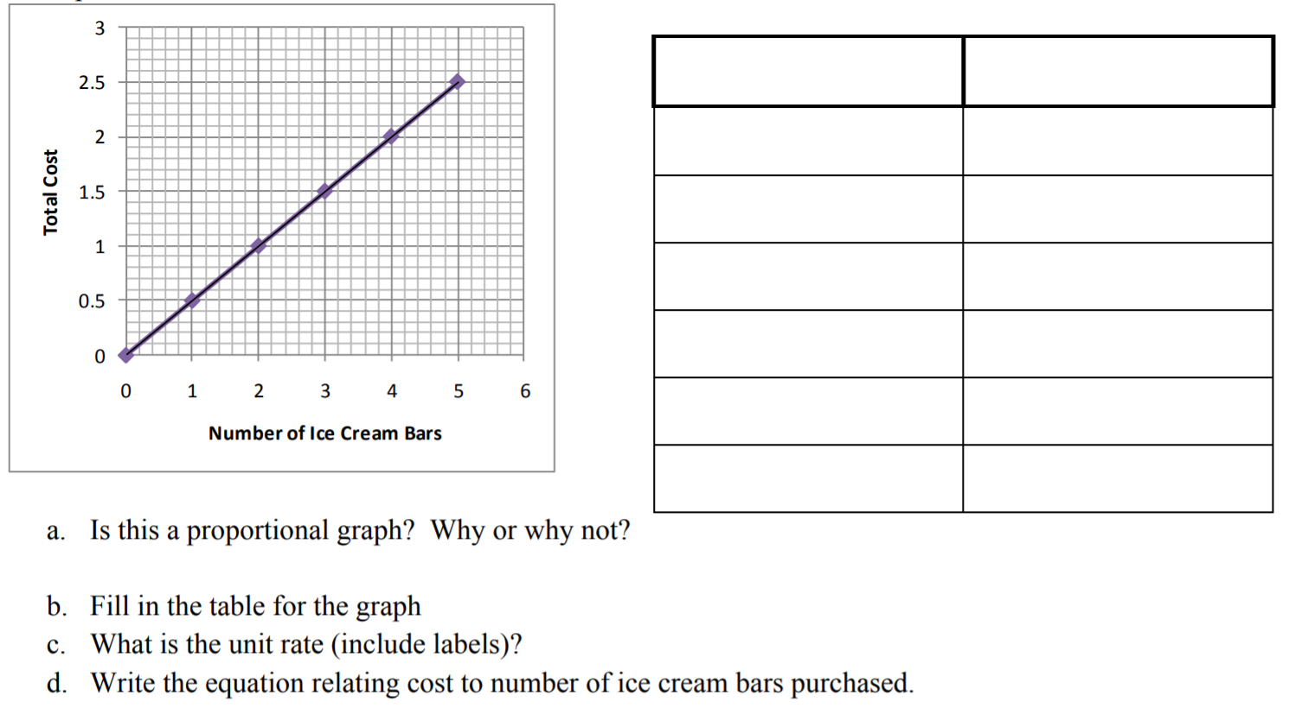
- Fill in the missing ratio values.  Is the table proportional? Explain why or why not: | - The amount of money Amy has saved is proportional to the number of weeks that have passed. This relationship is graphed below.  - Identify the unit rate or constant of proportionality and explain its meaning, related to this context.  - Explain the meaning of the points, (0, 0) and (4, 40), within this context.  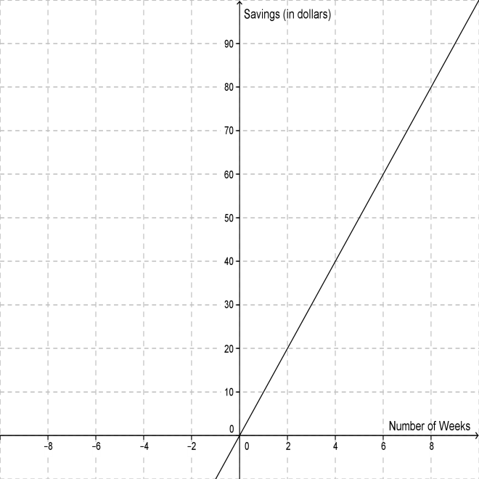

Put the cyclists in order from fastest to slowest, using math AND words to explain your reasoning.

